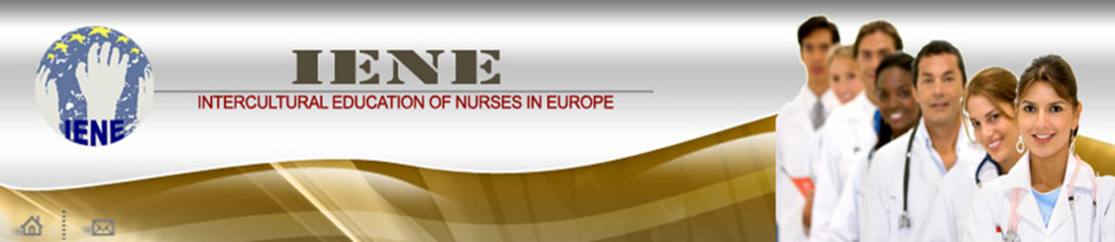

ERASMUS+ Programme –Key Action 2: Strategic partnership
Agreement number 2014-1-UK01-KA203-001629

TRAINING HEALTH CARE TEAMS IN INTERCULTURAL COMMUNICATION AND PATIENT SAFETY (IENE 5)

O2: European Model for developing intercultural communication skills and capacity of working in multidisciplinary/multicultural teams

The IENE5 Model for the MOOC

AUTHOR:
Middlesex University, UK

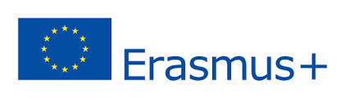  This project has been funded with support from the European Commission. This publication reflects the views only of the author, and the Commission cannot be held responsible for any use which may be made of the information contained therein. |  | 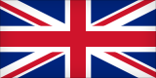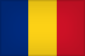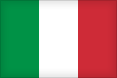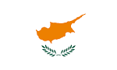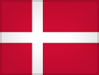  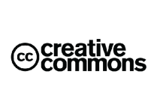
Introduction

The IENE5 project examines three key areas of learning: the enablers and barriers of intercultural communication within multicultural/multidisciplinary healthcare teams (MMHT) and how these could prevent or be the cause of avoidable patient safety incidents. This MOOC (Massive Open Online Course) is part of the IENE5 project.

More specifically this MOOC will address the following:

- What is intercultural communication?
- What are the characteristics of effective intercultural communication and how can we achieve them?
- What do we mean by Multicultural/Multidisciplinary Healthcare Teams (MMHT)?
- Why is effective intercultural communication essential to MMHT?
- What challenges do MMHTs face in learning to communicate through the cultural boundaries of each other’s cultures?
- What is patient safety?
- Why do we need to be concerned about it?
- Why effective intercultural communication within MMHT is the key to patient safety?

The overall design of this MOOC

The overall design of this MOOC is based on the model developed by Salmon (2013). The model describes five stages as the keys to active online learning:
1. Access and Motivation,
2. Online socialization
3. Information exchange
4. Knowledge construction
5. Development

(Salmon G (2013): E-tivities: the key to active online learning. 2nd Ed. NY Routlege)

The guiding values and philosophy for the MOOC

The IENE5 team believes that:
- each person has the capacity to learn using a variety of methods
- education opportunities should be made available to all people across the world
- education should not only benefit individuals but should also aim to benefit humanity as a whole
- education should provide the opportunities for individuals to learn with others from their community but also with others from diverse communities and different countries
- intercultural communication is of utmost importance in the promotion of understanding amongst people, and it is particularly essential for health professionals who are increasing working in multidisciplinary and multiprofessional teams
- the use of educational technologies should be promoted as essential ways to deliver education in the 21st century.

The educational principles of this MOOC

But before you get too deep into the content, I will ask you to watch a very brief animation of our approach to this short course. (You will find the link for the video at the end of the page).

The key educational principles used in this MOOC are:
- Independent and collaborative learning
- Reflection on own learning and experiences
- Creation and co-creation of knowledge
- Active interaction with inspiring activities and with the experiences of others
- Bite-sized learning
- Focus on a unique topic or small number of topics, for a short period
- Maximum use of available educational technologies and social media
- Peer facilitation
- Peer feedback
- Variety of levels and methods for assessing achievement

The MOOC’s Structure and Conceptual map
The MOOC structure includes four ‘topic /modules’and it is six weeks long and will.
 | WEEK 1 | WEEK 2 |  | WEEK 3 |  | WEEK 4 | WEEK 5 | WEEK 6
1 | Orientation
2 |  | Intercultural Comm/tion | MC  MD
3 |  |  |  | MCMD  Teams | P  S
4 |  |  |  |  |  | Patient (P)  safety (S)
5 |  |  |  |  |  |  | Synthesis/ Integration
6 |  |  |  |  |  |  |  | Assessment
The first week will be an orientation to the technology, to the educational approaches of the MOOC, its structure and an opportunity for the participants to introduce themselves to all other participants through uploading short profiles of themselves, in the specific area of the MOOC platform. The second week would focus on activities related to intercultural communication but with a small component which relates this topic to team working. The third week is devoted to the theme of working in multicultural and multidisciplinary teams, but with a small component which relates this topicto patient safety. The fourth week is devoted to patient safety whilst the fifth is a synthesis of the previous three weeks. The sixth week is devoted to the summative assessment and any catch up the participant needs to make.
The construction of the conceptual map of each topic week (also referred to as modules) was based on the priorities of learning identified during Output 1 which dealt with the priorities of learning through a needs assessment survey.

The MOOC Assessment Strategy

Assessment: There are two main elements of the assessment process. First the participants’ achievement of learning outcomes will be assessed formatively through self- assessment quizzes, and the MOOC’s ability to capture participant’s activity. Points will be awarded for completing the quizzes, for completing the activity of each day (individual learning), for taking part in discussions or other group activities (collaborative learning) and providing feedback to members of the participants’ groups.

The second element is the summative assessment. This consists of the production of an artifact which captures the essential elements of their learning and a plan of future action. The artifacts could be a short animation, a power point presentation, a podcast, a short video and so on. The plan of future action should be embedded in the artifact and should contain a description of an action to be taken which will be based on their MOOC learning on MMHT, IC and PS, the target group intended for, the desired outcomes, the method to be used to execute the plan and the timescale. Points will be awarded to each artifact by the facilitators based on the following criteria:
- Completeness and comprehensiveness of all elements (artifact and plan of action)
- Creativity and innovation
- Usability
- Reflexivity
The award of MMHT badges
In addition to or instead of the ICN credits, achievement badges will be awarded based on the following criteria:

Individual achievement badge: This badge will be awarded to those individuals who mostly engaged with individual learning activities. Such individuals would have accrued 70 out of 140 points awarded for individual learning.

Group achievement badge: This badge will be awarded to those individuals who engaged in individual and group activities and provided peer feedback. Such individuals would have accrued 200 out of 340 points awarded for group learning.

Community achievement badge: This badge will be awarded to those individuals who engaged in individual, group and community activities and completed the summative assessment (my MOOC journey and my plan of action). Such individuals would have accrued 400 out of 500 points awarded for community learning.

Verification of Participation and the award of ICN credits: In order to achieve a successful completion of the course and the award of ICN credits, a participant will need to fulfill all the requirements of the programme for the whole 6 weeks. No one will be eligible for the International Credits unless successfully completing all the requirements of the programme. Attendance verification is captured electronically by the MOOC platform through the course management facility which enables the facilitators to monitor each participant and track their progress. The participants can also monitor their own progress and achievements.

RP/2016/IENE5MOOCmodel

